**Personal, Social and Emotional Development:**

Can talk about the feelings ‘happy’ and ‘sad’

Recognises when they might be ‘happy’ or ‘sad’ and responds appropriately

Children celebrate accomplishment of goals

Understands that they need to wait their turn, using props to support them

Selects and uses activities and resources, with help, when needed.

Knows that they need some resources e.g. an apron for painting.

Sometimes shares resources with adults and peers, sometimes requiring support

Recognises their own belongings and knows to store their items on their peg

Can talk about the feelings ‘jealous’, ‘worried’ and ‘frightened’ and is aware of synonyms for previously learnt feelings

Recognises the feelings of characters in stories

Children are able to explain what they are good at and what they need to practise

Children are developing resilience, trying to do something difficult which they want to achieve

Takes turns in games and group activities with some support

Shows confidence when playing in a small group and in new social situations

Children increasingly follow rules independently

Shares resources with friends if they are asked for something

Resolving conflicts by themselves, where possible, and not retaliating

Developing appropriate ways of being assertive

**Physical Development:**

Children will have a PE lesson with Mr Pierce on a Tuesday where they will be developing *‘Fundamental movements*.

**Gross:**

Rides a trike independently

Can throw a large ball with both hands

Catches a large ball from a short distance

Uses large-muscle movements to produce vertical and horizontal lines

Uses small-muscle movements to produce vertical and horizontal lines

Is aware of healthy and unhealthy foods

Independently accesses the outdoor area for exercise and knows why we need to exercise

Rides a balance bike, occasionally lifting up their feet

Skip, hop, stand on one leg and hold a pose

Walks along a bench independently

Uses large-muscle movements to produce squares

Uses small-muscle movements to produce squares

**Fine**

Begin to use scissors. Uses large tweezers, large nuts and bolts and is able to thread. Is able to use other large one-handed tools such as hammers

Uses Static tripod/quad grasp

Beginning to show strength in a particular hand

Use a comfortable grip with good control

Dynamic tripod grasp

Put their coat on by themselves and zip it up

**How do I express myself?**

**Colours**

Little Tors

**OUR learning map**

term – Autumn 1 – 2023

Pre-school & Reception



**Communication and Language:**

Listens to simple stories with a picture stimulus

Is beginning to listen to adults and other children

Communicates with survival language and with 1 or 2 words at a time

Children can articulate what they do and don’t like

Uses talk to communicate specific needs

Can listen to their friends and teachers for short periods of time

Listens carefully to rhymes and songs

Uses sentences of 4-6 words

Starts a conversation with an adult or friend and continues it

Uses talk to organise themselves and their play

Uses a wider range of vocabulary

Key events/dates:

**Toddler Group –** Every Friday morning

**Welly Walks ­–** We would love to get our weekly Welly Walks up and going again! To do this, we need at least two parent helpers for each date and any offers of help would be greatly appreciated. I will put a sign-up sheet on the door with dates on, please feel free to take a look.

**iTown** – We are hoping to arrange a visit to itown either this term or at the start of the next.

*Welcome back to or to our Little Tors EYFS unit. We are excited to see some old and new faces! This term we will be looking at who we are, how we express ourselves and learning about artists and colour. Colour plays a massive part in our lives from like and dislikes, how we express our emotions to how they change in the natural world around us.*



**Mathematics**:

I will be learning to count, recognise and order numbers to at least 10.

I will be learning to match numbers to quantities of groups to at least 10.

I will be learning to say the number one more/less than a given number up to 10.

I will be learning to name and describe simple 2D.

I will be sorting shapes and objects by colour and size • I will be learning to create repeating patterns.

I will be comparing myself, my friends and family and putting my findings into simple graphs and tables

I will be ordering the events in my day.

**Literacy/Phonics**:

Stories we will look at during story of the fortnight: 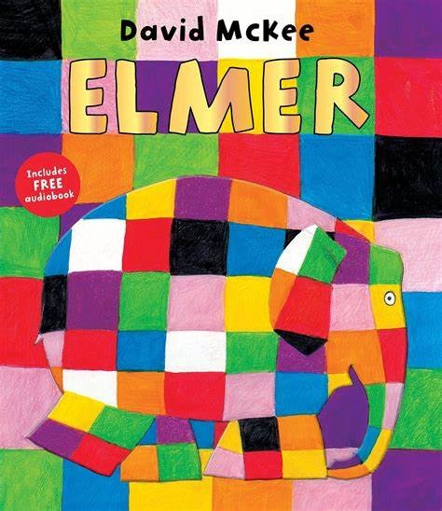 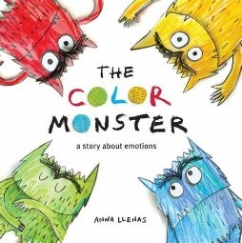 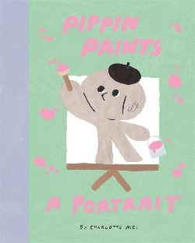

**Reading**

Knows how we hold a book, which way we turn the pages and that we read from left to right

Enjoys listening to stories

Recognises their name

Can engage in short conversations about stories

Is able to explain what the job of an author and illustrator are

Reads individual letters by saying the sounds for them

Reads phase 2 common exception words

Reads words with 1 syllable

Can answer closed questions involving literal retrieval

Can answer open questions involving literal retrieval

**Writing**

Participates in fine motor activities

Children can write the first letter of the name

Draws circles, lines and other shapes

Children are able to write initial sounds

Spells words by identifying sounds and writing the letters

Writes some letters accurately

Children can write all of their first name

**Expressive Arts and Design**:

Use pre-made paints and are able to name colours

Can hold a paintbrush in the palm of their hand

Print with large blocks and larger sponges

Makes marks. Draws circles and lines.

Builds towers by stackings objects

Explores instruments and is beginning to name them (drum, tambourine, maraca, triangle...)

Knows some words when singing

Plays with familiar resources

Able to mix primary colours to make secondary colours

Can use thin brushes to add detail

Print with small blocks, small sponges, fruit, shapes and other resources

Draws potato people (no neck or body)

Children are able to draw simple things from memory

Adds other materials to develop models (tissue paper, glitter...)

Builds simple models using walls, roofs and towers.

Manipulates clay (rolls, cuts, squashes, pinches, twists...)

Is able to name a wide variety of instruments (also including chime bars, glockenspiels, xylophones)

Plays a given instrument to a simple beat

Sings in a group, trying to keep in time

Participates in small world play related to rhymes and stories

**Understanding the World**:

**Past and Present**

Able to say who they are and who they live with

Sequence family members by size and name (baby, child, adult)

Comments on fictional characters in stories

Can talk about past and upcoming events with their immediate family

Is able to discuss different occupations of family members

Sequence family members, explaining who they are (baby, toddler, child, teenager, adult, elderly)

**Geography**

Knows what a map is used for

Knows where they live (house, flat, bungalow)

Can articulate what daily life is like for them in our country

Talk about what they see in their own environment (school/home) using a wide vocabulary

Identifies features on a simple map – in familiar environments such as the classroom and outdoors

Can explain features of other homes

Talk about local environments (their road, the park, library,

**The Natural World**

Explores how things work

Uses senses in hands on exploration

Understands that the weather changes and that in different countries you have different weather

Understands the difference between plants and animals

Can identify what you need to wear for each season and why

Can name their 5 senses

Explores and talks about forces (push and pull)

**People, Cultures and Communities**

Talk about our families and our town

Know some similarities and differences between my family and my friends

Comments on recent pictures of experiences in their own life. “This was me at the farm...”

Knows that there are special places of worship

Knows that there are differences between what people believe

Comments on recent pictures of celebrations in their own life. “This was me celebrating Diwali”

Developing positive attitudes about differences between people

**How do I express myself?**

**Colours**

Little Tors

**OUR learning map**

term – Autumn 1 – 2023

Pre-school & Reception