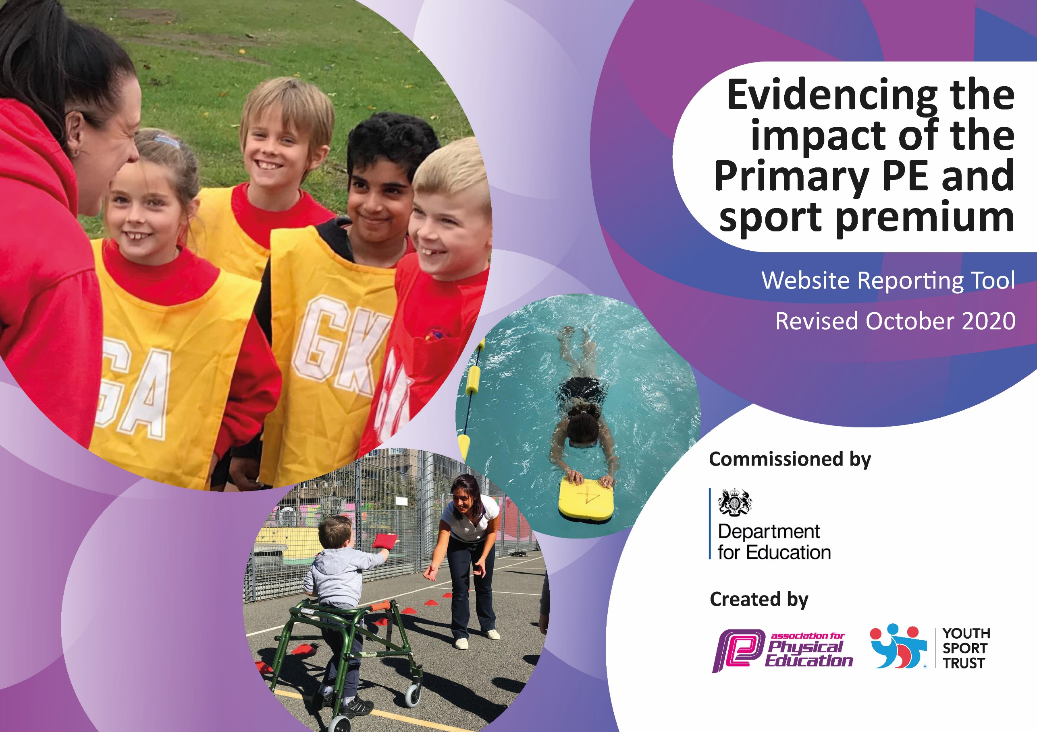
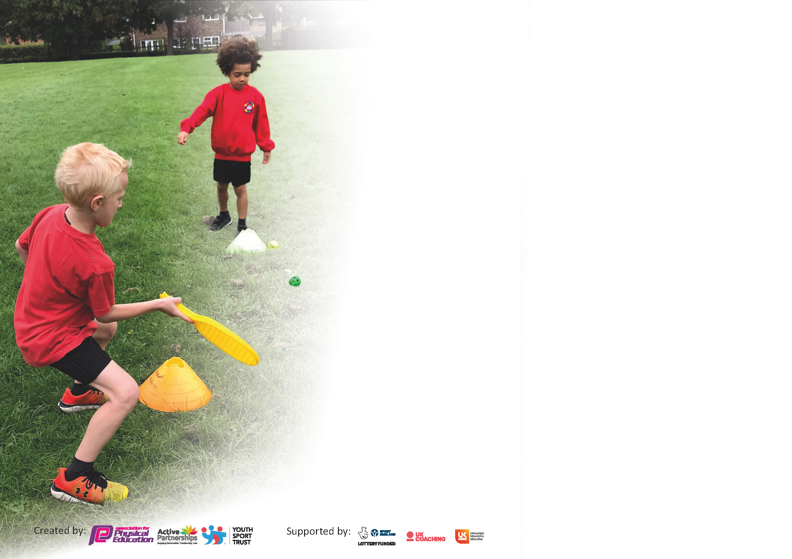

It is important that your grant is used effectively and based on school need. The Education Inspection Framework (Ofsted 2019 p64) makes clear there will be a focus on ‘whether leaders and those responsible for governors all understand their respective roles and perform these in a way that enhances the effectiveness of the school’.

Under the Quality of Education criteria (p41) inspectors consider the extent to which schools can articulate their curriculum (INTENT), construct their curriculum (IMPLEMENTATION) and demonstrate the outcomes which result (IMPACT).

To assist schools with common transferable language this template has been developed to utilise the same three headings which should make your plans easily transferable between working documents.

Schools must use the funding to make additional and sustainable improvements to the quality of Physical Education, School Sport and Physical Activity (PESSPA) they offer. This means that you should use
the Primary PE and sport premium to:

- Develop or add to the PESSPA activities that your school already offer
- Build capacity and capability within the school to ensure that improvements made now will benefit pupils joining the school in future years

Please visit gov.uk for the revised DfE guidance including the 5 key indicators across which schools should demonstrate an improvement. This document will help you to review your
provision and to report your spend. DfE encourages schools to use this template as an effective way of meeting the reporting requirements of the Primary PE and sport premium.

We recommend you start by reflecting on the impact of current provision and reviewing the previous spend.

Schools are required to publish details of how they spend this funding as well as on the impact it has on pupils’ PE and sport participation and attainment by the end of the summer term or by 31st July 2021 at the latest.

** In the case of any under-spend from 2019/20 which has been carried over this must be used and published by 31st March 2021.

We recommend regularly updating the table and publishing it on your website throughout the year. This evidences your ongoing self-evaluation of how you are using the funding to secure maximum, sustainable impact. Final copy must
be posted on your website by the end of the academic year and no later than the 31st July 2021. To see an example of how to complete the table please click HERE.
Created by: Supported by:

Please note: Although there has been considerable disruption in 2020 it is important that you publish details on your website of how you spend the funding - this is a legal requirement.
Support for review and reflection - considering the 5 key indicators from DfE, what development needs are a priority for your setting and your pupils now and why? Use the space below to reflect on previous spend and key achievements and areas for development.

N.B. In this section you should refer to any adjustments you might have made due to Covid-19 and how these will influence further improvement.
Key achievements to date until July 2021: | Areas for further improvement and baseline evidence of need:
KI1  - All students given 60 minutes of physical activity through constructive lunchtimes activities and whole-school morning movement activities.  KI2  - Trust employed PE specialise to lead subject within the school.  - Profile of PE raised across the school through a wide range of curricular opportunities and extra-curricular clubs for all students.  KI3  - CPD has been provided for all teaching staff and has improved staff confidence of delivering a range of PE activities.  KI4  - New PE curriculum has been rolled out, which includes a greater range of sports and activities, increasing the opportunity for students.  - Wide variety of extra-curricular opportunities available for all students to widen their experiences.  - Whole-school community day to provide wider variety of activities.  KI5  Despite difficulties surrounding COVID-19 restrictions, all students in KS1 & 2 have taken part in a competitive virtual festival against other schools. | - Additional festivals for KS1, KS2 and EYFS (COVID permitting). This will allow all students in the school to take part in competitive activity (KI 5).  - Wider opportunities for student to take part in outdoor and adventurous activities/gain experiences outside of the school in areas which aren’t covered in the PE curriculum e.g. rock climbing, sailing etc.  - Greater personalised CPD for teaching staff to further develop confidence teaching a wide range of PE activities.

Moretonhampstead Planned spending 2021-22

Action Plan and Budget Tracking
Capture your intended annual spend against the 5 key indicators. Clarify the success criteria and evidence of impact that you intend to measure to evaluate for pupils today and for the future.

Academic Year: 2021/22 | Total fund allocated: £17,120 | Date Updated: 19/07/2021
Key indicator 1: The engagement of all pupils in regular physical activity – Chief Medical Officers guidelines recommend that primary school pupils undertake at least 30 minutes of physical activity a day in school |  |  |  | Percentage of total allocation:
Intent | Implementation |  | Impact
Your school focus should be clear what you want the pupils to know and be able to do and about  what they need to learn and to  consolidate through practice: | Make sure your actions to achieve are linked to your intentions: | Funding allocated: | Evidence of impact: what do pupils now know and what can they now do? What has changed?: | Sustainability and suggested next steps:
Engage all students in daily active playtimes.  All students participate in the Golden Mile each day for additional physical activity.  Increase number of extracurricular activities available for students  Develop PE in line with whole-school improvement plan - Give students access to greater ICT and video analysis opportunity to develop their learning | Equipment/resources to be purchased so students of all ages have access to a range of different physical activities during play times.  Increase access to physical development in preschool/EYFS by purchasing resources to support fine & gross motor skills.  We have set up a daily running programme which tracks students running distances over the school year. Classed participate each day to increase their distance and subsequently their physical activity.  Extra-curricular clubs are available for students after school each day. These are led by external providers as well as class teachers/PE teacher.  Purchase of ICT resources to use for PE lessons + future school projects. | £372  £600  No cost  no cost with staff  £2,572 | We have seen a substantial increase in the number of students who are physically active during the school day. The more unique sports have been really popular in engaging those who in the past have been disengaged in sport and physical activity. Skipping ropes have been very popular during break times.  The number of students in KS1 actively participating in clubs has increased. Still trying to encourage as many KS2 – however lots have current commitments to sports teams/clubs.  Technology allowing data analysis, video analysis, instant feedback on technique and skills.  Improving students’ learning in both PE and computer literacy. | Equipment owned by the school so can be used next year and beyond. Next steps: additional lunchtime resources for all students.  Teachers deliver clubs on rotation to ensure these are sustainable.  External providers set up for next year.  Use of technology in PE will be a continual focus across the school as part of the whole-school improvement plan.

Key indicator 2: The profile of PESSPA being raised across the school as a tool for whole school improvement |  |  |  | Percentage of total allocation:
 |  |  |  | 6%
Intent | Implementation |  | Impact
Your school focus should be clear what you want the pupils to know and be able to do and about  what they need to learn and to  consolidate through practice: | Make sure your actions to achieve are linked to your intentions: | Funding allocated: | Evidence of impact: what do pupils now know and what can they now do? What has changed?: | Sustainability and suggested next steps:
Specialist PE staff to raise profile of PE and school sport to drive forward improvement in the subject and whole school community.  Use PE as a driver for improvements in student learning.  Increase students’ excitement of PE lessons through specialist resources. | The school has employed a specialist PE teacher.  New PE curriculum and planning rolled out to give staff the tools to improve the quality of teaching and learning through sport and physical activity.  Purchase of specific PE equipment/resources for each activity included in the PE curriculum. | See KI3  No cost (provided by PE specialist – see KI3)  EYFS, KS1 & KS2 = £1000 | All students have a high-quality PE lesson from a specialist teacher. Impact of PE specialist has meant that PE is a valuable part of the curriculum and there is greater enthusiasm for the subject.  Staff have access to regular CPD to improve their delivery of quality PE.  Higher quality learning is now taking place in PE. Link made to other curriculum subjects also used within PE lessons to develop wider student understanding.  Improved quality of PE lessons and amount of sport/physical activity taking place across the school.  Improved profile of PE lessons due to the access to specialist equipment.

Key indicator 3: Increased confidence, knowledge and skills of all staff in teaching PE and sport |  |  |  | Percentage of total allocation:
Intent | Implementation |  | Impact
Your school focus should be clear  what you want the pupils to know  and be able to do and about  what they need to learn and to  consolidate through practice: | Make sure your actions to  achieve are linked to your  intentions: | Funding  allocated: | Evidence of impact: what do  pupils now know and what  can they now do? What has  changed?: | Sustainability and suggested  next steps:
Regular professional development for all teaching staff, promoting higher quality teaching of PE.  Regular afterschool CPD support for less confident staff, NQT’s. This will be made available for schools to come together to share expertise. | Employed school PE teacher to deliver regular training for staff to develop confidence in a wide range of activities. Detailed and personalised CPD programme in place for all class teachers.  Class teachers work with PE specialist to assess students and have regular feedback about their own delivery of PE.  Working group set up to regularly communicate and share best practice. | £9025  No cost | All staff have received regular CPD from PE specialist. Teaching staff are now more confident delivering the wide variety of activities included within the PE curriculum.  Staff confidence increased in a range of activities and will be shown in lessons next year when working with Trust PE Lead. | PE teacher employed on a permanent contract to continue developing staff competence.  Evidence made by PE teacher and day is planned again with alternative activities next year.

Key indicator 4: Broader experience of a range of sports and activities offered to all pupils |  |  |  | Percentage of total allocation:
Intent | Implementation |  | Impact
Your school focus should be clear | Make sure your actions to | Funding | Evidence of impact: what do | Sustainability and suggested
what you want the pupils to know | achieve are linked to your | allocated: | pupils now know and what | next steps:
and be able to do and about | intentions: |  | can they now do? What has
what they need to learn and to |  |  | changed?:
consolidate through practice:
Diverse PE curriculum offering students a range of sports and activities.  Develop leadership opportunities for students in KS2.  All students to take part in outdoor/adventurous activities.  Use specialist providers to offer students exciting activities.  Swimming for all year groups. | Our PE curriculum is designed by specialist PE teacher. This gives students the chance to learn 12 sports and activities over a 2-year cycle.  Set up a new Sports Leaders Programme for KS2 students.  School to fund trips for all students in KS1 & KS2.  Healthy living week – all students will participate in a week of fun-filled activities, doing things which aren’t taught on the PE curriculum – broadening their experiences.  6-week block of lessons given by swimming staff. | Included in KI3 (£9025)  £250  KS2 = £958.40  £900  £500 | Students enjoy a huge variety of activities and this has developed a love for sports and PA.  KS2 students have successfully began the sports leaders programme, which has had an impact on younger students across the school. This has also given KS2 students their first step towards leadership for life as well as improving your interpersonal skills, both of which will help with transition into secondary school.  All students took part in a range of new and exciting experiences from specialist providers during their Sports Enrichment Day.  Rugby  Football  Dance  Yoga  Team Building  Fencing  Archery  Music  Martial Arts | Curriculum in place for next year, with continued high-quality teaching.  Yearly programme  Continuation of funding will allow trips in the future.  Expand Residential Trips to all of KS2.  KS1 to have more trips; climb centre, kayaking, water safety, and surfing etc...  Look for other healthy living initiatives and trips for this week.  Sports Enrichment Days to continue and provide whole school with active opportunities outside of the curriculum.  Links made with external providers so they can offer further events like this in the future.

Key indicator 5: Increased participation in competitive sport |  |  |  | Percentage of total allocation:
Intent | Implementation |  | Impact
Your school focus should be clear | Make sure your actions to | Funding | Evidence of impact: what do | Sustainability and suggested
what you want the pupils to know | achieve are linked to your | allocated: | pupils now know and what | next steps:
and be able to do and about | intentions: |  | can they now do? What has
what they need to learn and to |  |  | changed?:
consolidate through practice:
Offer students trust-wide competitions.  Fixtures for schools to compete against others on a regular basis | All students to have the opportunity to represent their school in the 2021-22 academic year. 10 events taking place over the year.  - KS2 tag rugby  - KS2 cross country  - EYFS & KS1 multi-skills  - Year 3 & 4 Handball  - KS2 Football  - Year 3 & 4 striking and fielding.  - Basketball Yr 3 & 4  Link Academy league to be set up. | Facility hire = £100  Transport = £120  No cost | All students have proudly represented their school at an event this year, with many KS2 students participating in multiple events and fixtures. | More events planned for next academic year, run by PE team.  This will again cover all year groups and provide more options for KS1, Gifted and Talented and Inclusion Games.  Fixtures set up for next year

Total sports grant: 17,120
Total projected spend: 16,397
Signed off by
Head Teacher: | Alex Waterman
Date: | 20.7.2022
Subject Leader: | Tayler Pierce
Date: | 20/07/22
Governor:
Date:

